Washington Latin’s Spring Musical 2027 is now!
THE ADDAMS FAMILY
(performing February 18 to 21, 2027)
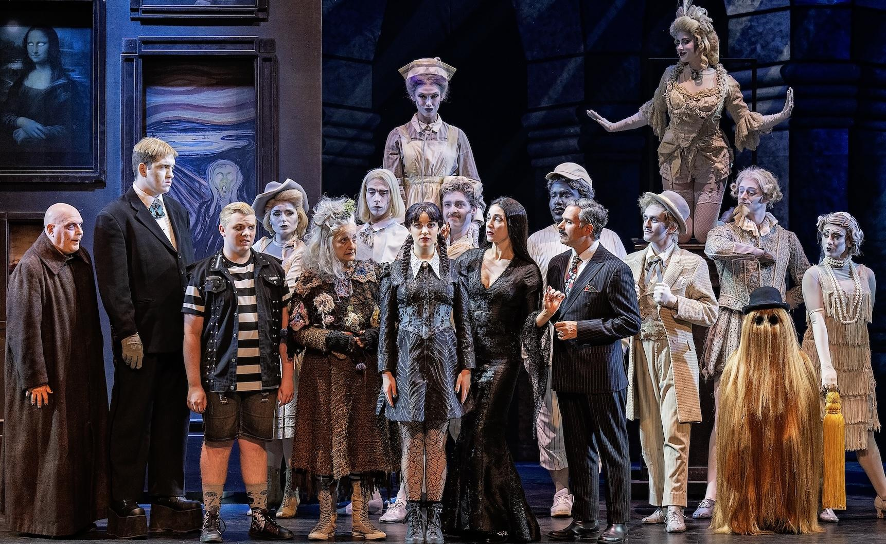

Before you audition for Latin's school-wide production (5th to 12th graders) - you should check out the “Resource Guide for THE ADDAMS FAMILY Auditions.” The QR code will be posted near Student Cell Phone pick-up locations.

Middle School SINGING Auditions are:
Wednesday, Thursday, Friday, September 23rd to 25th after school.

Upper School SINGING Auditions are:
Thursday, October 1st after school.
Monday, October 5th after school.
Tuesday, October 6th after school.

DANCING Auditions will be held at the following times:
Middle School: Wednesday, after school 9/30 until 4pm. (Additional dance times will be added.)
Upper School: Thursdays during Lunch, 9/24 and 10/8.

Sign up slots are posted outside the door to the Theater room 111.
If you want to join the stage or construction crew, please email Mr. Baldwin.

