Washington Latin’s Spring Musical 2027 is now!
THE ADDAMS FAMILY
(performing February 18 to 21, 2027)
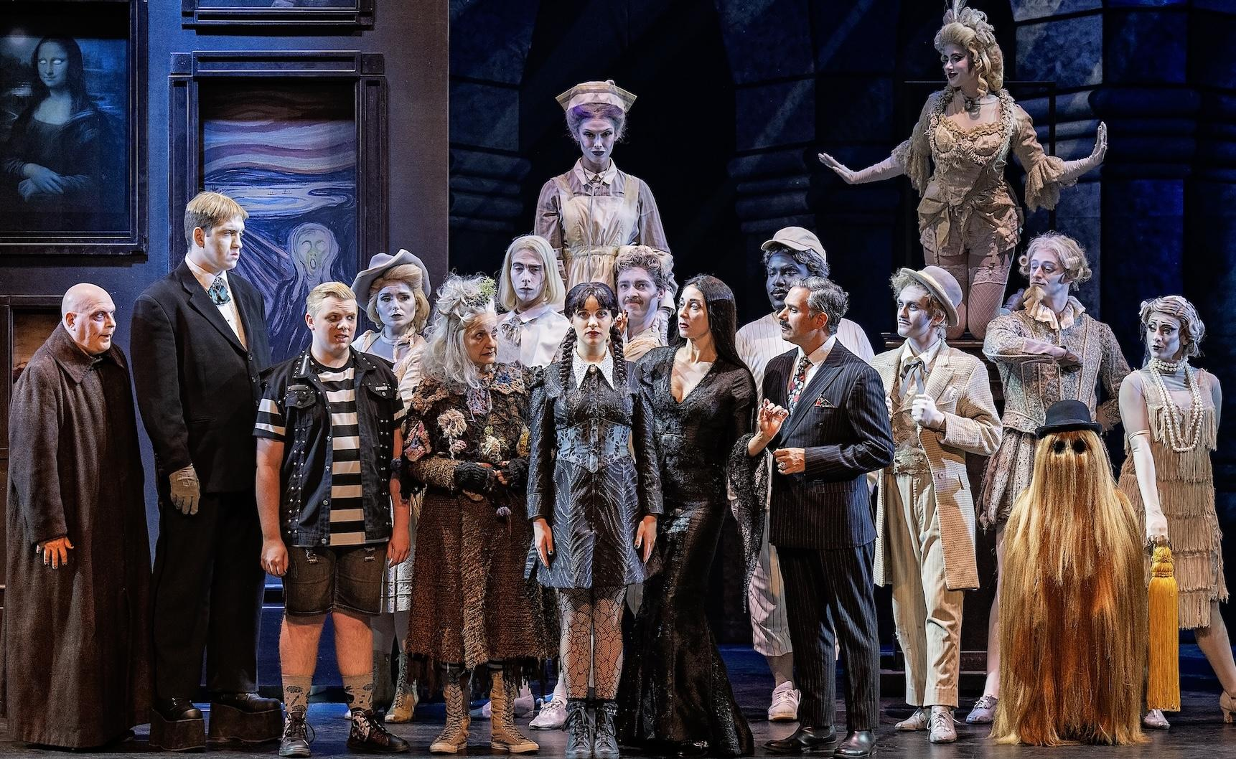

Before you audition for Latin's school-wide production - you should check out the “Resource Guide for THE ADDAMS FAMILY Auditions.” The QR code is posted near Student Cell Phone pick-up locations.

Upper School SINGING Auditions continue on:
Monday, October 5th after school.
Tuesday, October 6th after school.

DANCING Auditions will continue on the following day and time:

Upper School: Thursday during Lunch, 10/8.

Sign up slots are posted outside the door to the Theater room 111.
If you want to join the stage or construction crew, please email Mr. Baldwin.

